**DATA MODELING IN POWER BI**

What is Data Modeling in Power BI?

Data modelling is the process of analyzing and defining all the different data your business collects and produces, as well as the relationships between those bits of data.

Why is Data Modeling needed in Power BI?

* Data Modeling is ensured consistency in naming conventions, default values.
* Dara Modeling helps in the visual representation of data and enforces business rules.

Relationship or Cardinality types in Power bi data modeling.

Three types of relationship:

* One to One: A one-to-one relationship can be created when both tables each contain a column of common and unique values.

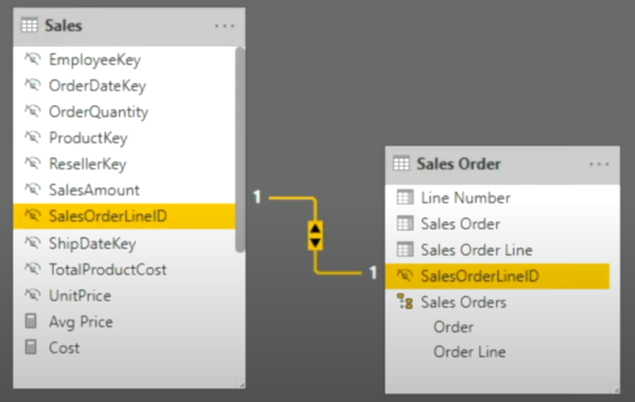

* One to Many: In a one-to-many relationship, the column in one table has only one instance of a particular value, and the other related table can have more than one instance of a value.

* Many to Many: a many-to-many relationship is a type of cardinality that refers to the relationship between two entities, say, A and B, where A may contain a parent instance for which there are many children in B and vice versa.

Disadvantage of Many to Many relationships is that it reduce the performance of power bi.

To Avoid Many to Many relationships or Duplication of values, we can break the many-to-many relationship into two one-to-many relationships by using a third table, called a join table or bridge table. Each record in a join table includes a match field that contains the value of the primary keys of the two tables it joins.

The Bridge table or Join table makes the database and relationship easy to understand and it prevents data duplication.

**Types of Data Warehouse Schema in power bi.**

* **Star Schema:**

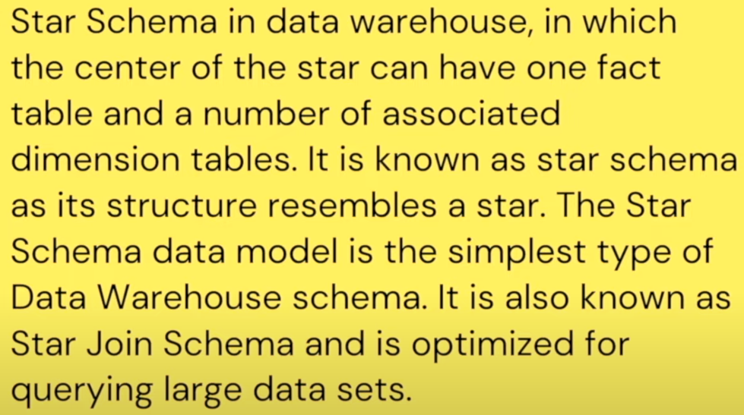

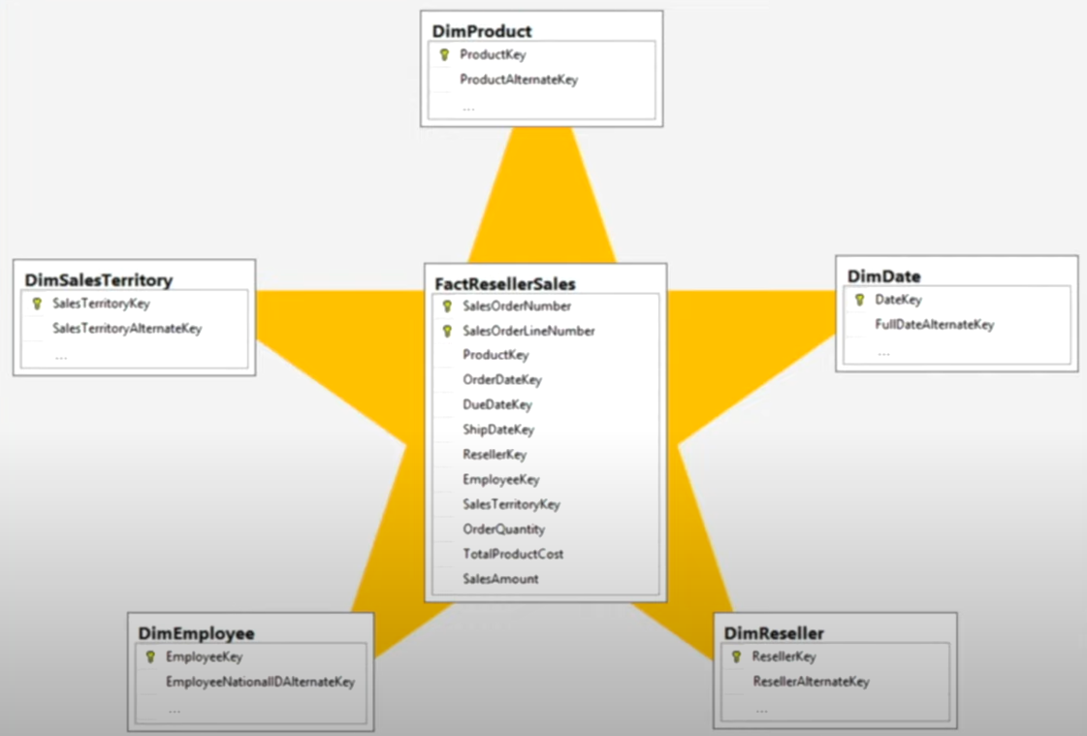

* **Snowflakes Schema:**

A Snowflake Schema is an extension of Star Schema, and it’s adding additional dimensions. The dimension tables are normalized which splits data into additional tables

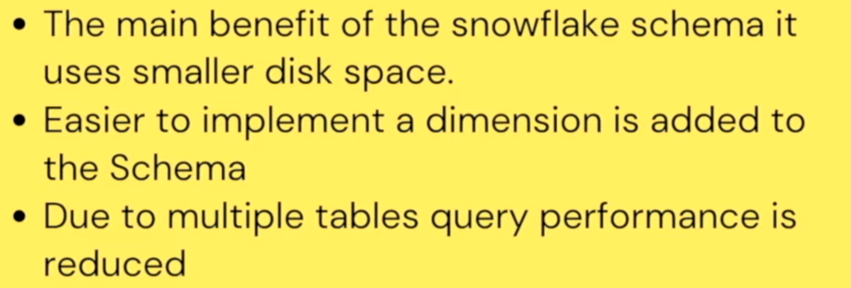

At the time of creating any type of schema model. Only one relationship is Active, and others are Inactive between two tables.

How we can identify Active Relationship and Inactive Relationship:

Active Relationship will always show as Sold Line and   
Inactive Relationship will always show as Dotted Line.

We can use Inactive Relationship by using DAX (Userelationship).

**What is Fact Table in Power BI?**

* **Fact Table:** Fact tables contain the data that we want to analyze. The data is usually transactional in nature. A fact table also needs to include the keys to the related dimensions. In our sales data example, the Sales table is a fact table that contains keys to the related dimension tables:

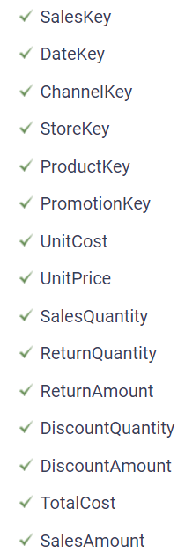

**Dimension Tables:**

Dimension tables provide the information to help us describe, categorize, group, or filter the data in the fact tables. You would normally have a different dimension table for each way that you want to analyze or report on your fact data.

In our sales data example, the following dimension tables are in the database:

